**SOFT COMPUTING**

**ASSIGNMENT -4**

**Perumalla Dharan**

**AP21110010201**

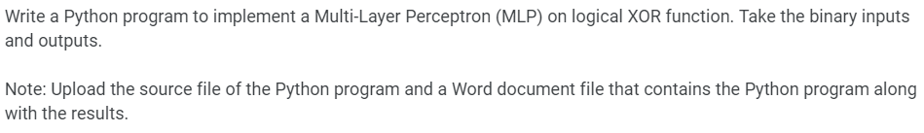

*import* numpy *as* np

class MLP:

def __init__(*self*, *learning_rate*=0.1, *iterations*=10000):

*self*.learning_rate = *learning_rate*

*self*.iterations = *iterations*

*self*.weights_input_hidden = np.random.uniform(-0.5, 0.5, (2, 2))

*self*.bias_hidden = np.zeros(2)

*self*.weights_hidden_output = np.random.uniform(-0.5, 0.5, (2, 1))

*self*.bias_output = np.zeros(1)

def sigmoid(*self*, *x*):

*return* 1 / (1 + np.exp(-*x*))

def predict(*self*, *X*):

hidden_input = np.dot(*X*, *self*.weights_input_hidden) + *self*.bias_hidden

hidden_output = *self*.sigmoid(hidden_input)

final_input = np.dot(hidden_output, *self*.weights_hidden_output) + *self*.bias_output

final_output = *self*.sigmoid(final_input)

*return* np.round(final_output)

def train(*self*, *X*, *y*):

*for* epoch *in* range(*self*.iterations):

*for* i *in* range(len(*X*)):

hidden_input = np.dot(*X*[i], *self*.weights_input_hidden) + *self*.bias_hidden

hidden_output = *self*.sigmoid(hidden_input)

final_input = np.dot(hidden_output, *self*.weights_hidden_output) + *self*.bias_output

final_output = *self*.sigmoid(final_input)

y_pred = np.round(final_output)

*if* y_pred != *y*[i]:

output_error = *y*[i] - final_output

hidden_error = output_error.dot(*self*.weights_hidden_output.T)

*self*.weights_hidden_output += *self*.learning_rate * np.outer(hidden_output, output_error)

*self*.bias_output += *self*.learning_rate * output_error

*self*.weights_input_hidden += *self*.learning_rate * np.outer(*X*[i], hidden_error)

*self*.bias_hidden += *self*.learning_rate * hidden_error

def print_weights(*self*):

print("Input-Hidden Weights:\n", *self*.weights_input_hidden)

print("Hidden-Output Weights:\n", *self*.weights_hidden_output)

X = np.array([[0, 0],

[0, 1],

[1, 0],

[1, 1]])

y = np.array([[0], [1], [1], [0]])

mlp = MLP(*learning_rate*=0.1, *iterations*=10000)

mlp.train(X, y)

mlp.print_weights()

predictions = mlp.predict(X)

print("Predictions after training:")

print(np.round(predictions))

Output -

